**Project Report**

**Under the supervision of**

**Dr. Rajiv Verma, Associate Prof.**

**Department of Mechanical Engineering**



Department of Mechanical engineering

National Institute of Technology

Kurukshetra-136119, Haryana (India)

Aug –Nov, 2024

**Declaration**

We hereby declare that this Project report entitled “Supply Chain Network Design for BONN” is an authentic record of our own work done under the supervision of **Dr. Rajiv Verma, Associate Professor, Mechanical Engineering Department** carried out during a period from August 2024 to November 2024.

**Date:** 4th November, 2024

**Submitted By: Submitted to:**

Aakash Khanna (12117038) Dr. Rajiv Verma

Mohit Gupta (12117051) Associate Prof.

Raj Gupta (12117018)

Rahul Rao (12117037)

Suyash Ranjan Mishra (12117047)

Umang Raj Verma (12117043)

**Acknowledgement**

We would like to express my heartfelt gratitude to the National Institute of Technology Kurukshetra for providing me with the opportunity and resources to undertake this final-year project on the design and optimization of a supply chain network for BONN. Being part of an institution that prioritizes practical learning and real-world applications has been a transformative experience, and We are deeply grateful to the Director of NIT Kurukshetra for supporting projects like this within the curriculum, which allow students to connect academic knowledge with industry practices.

We would like to extend my sincere and special thanks to my faculty mentor, Prof. Rajiv Verma, Associate Professor, Mechanical Engineering, for his invaluable guidance, constructive feedback, and continuous support throughout this project. His insights have been crucial in shaping our understanding of supply chain optimization and analytical methodologies. Prof. Verma’s mentorship has not only helped in navigating challenges encountered during this project but has also inspired us to adopt a structured, analytical approach toward problem-solving.

We also wish to thank all those who have supported me in various ways throughout the project. To family, whose unwavering support and encouragement have been a source of strength, We owe our deepest gratitude. Their faith in us has motivated us to persevere and overcome every challenge along the way.

This project would not have been possible without the support and contributions of everyone mentioned. Thank you all for your invaluable assistance.

**Abstract**

The fast-moving consumer goods (FMCG) industry demands an agile and cost-efficient supply chain to meet dynamic consumer needs. This project focuses on designing an optimized supply chain network for the Bonn Group of Industries, a leading FMCG brand known for its baked goods. The study integrates advanced data analytics, machine learning, and operations research techniques to identify optimal locations for manufacturing plants and distribution warehouses across India.

The project begins with a comprehensive case study of Bonn's operations, analyzing demand locations and transportation costs. Demand estimation leverages Python-based data analytics and clustering techniques, including K-Means and sub-clustering, to map high-demand regions effectively. The weighted center of gravity method is then applied to pinpoint optimal facility locations, supported by geospatial visualizations using Folium.

Two versions of the supply chain network were designed and evaluated based on layout and cost. The results highlight significant improvements in operational efficiency and cost reduction. The final solution provides actionable insights into network optimization, demonstrating scalability for broader FMCG applications. The report concludes by exploring the potential of AI/ML advancements in revolutionizing supply chain management.

This project serves as a case study and a practical application of data-driven methodologies, showcasing the transformative impact of technology on supply chain design and decision-making.

**Contents**

Declaration

Acknowledgement

Abstract

**Chapter 1 INTRODUCTION**

1.1 Background of Project

1.2 Objective of the Project

1.3 Scope

1.4 Learnings

**Chapter 2 CASE STUDY OF BONN**

2.1 Overview of BONN’s Operations

2.2 Demand Locations in India

2.3 Transportations Cost Analysis

**Chapter 3 DEMAND ESTIMATION USING PYTHON (DA + ML)**

3.1 Demand Mapping on Map

3.2 Clustering Techniques

3.3 Sub-Clustering  **Chapter 4 FINDING OUT BEST POSSIBLE LOCATIONS**

4.1 Theory of centre of Gravity in SCM

4.2 Calculation Methodology

4.3 Results

**Chapter 5 Finalising Facilities and their Capacity**

5.1 Plant Selection

5.2 Capacity Allocation

5.3 Distribution Warehouse

5.4 Capacity Allocation

**Chapter 6 Logistics Planning**

6.1 Third party vs Self Sufficient

6.2 Available Third Parties

6.3 Pros and cons

6.4 Self Sufficiency

6.5 Pros and Cons

6.6 Final Verdict

**Chapter 7 VISUALIZING THE NETWORK & COSTING: Version 1**

Network Design and Cost Analysis

7.1 Proposed Network Layout

7.2 Cost Analysis

7.2 Pros and Cons

**Chapter 8 VISUALIZING THE NETWORK & COSTING: Version 2**

Network Design and Cost Analysis

8.1 Proposed Network Layout

8.2 Cost Analysis

8.2 Pros and Cons

**Chapter 9 COMPARISON BETWEEN OF V1 & V2**

**Chapter 10 FINAL SOLUTION**  
  
  
**Chapter 11 FUTURE OF AI/ML IN SUPPLY CHAIN**

**REFERENCES**

**Introduction**

**1.1 Background**

Supply chain management (SCM) is a core component of operations in industries such as manufacturing, logistics, and retail. It involves the planning and oversight of product movement from production points to end customers. An optimized supply chain minimizes costs, maximizes efficiency, and ultimately boosts customer satisfaction.

In the food manufacturing industry, companies face challenges like fluctuating demand, high transportation costs, and the need for strategically located distribution centres. Production engineers play a crucial role in designing efficient supply chain networks by optimizing transportation, storage, and distribution. Through effective design, engineers contribute to reduced operational costs and improved service levels.

This project focuses on SCM optimization for BONN, a prominent food manufacturing company in India. By identifying high-demand areas and optimizing transportation routes, this study seeks to create a supply chain network that reduces costs while meeting demand efficiently by critically locating the production centres.

**1.2 Objective**

The primary objective of this project is to design a cost-effective supply chain network for BONN that minimizes transportation expenses and efficiently serves demand locations across India. By leveraging clustering techniques such as K-means and the center-of-gravity method, we aim to identify optimal distribution centers and strategic transportation routes to enhance BONN’s supply chain.

**1.3 Scope**

This project covers:

* A case study analysis of BONN’s current supply chain operations
* Demand mapping across major cities and states in India
* Cluster and sub-cluster formation using K-means and silhouette score
* Centre of gravity calculations to determine ideal distribution centres
* Cost analysis for the proposed network design.

**1.4 Learnings**

This project has provided significant insights and practical skills that will benefit us as final-year mechanical engineering students preparing to enter professional roles:

* **Application of Analytical Techniques:**  
  By employing clustering algorithms like K-means and advanced methods like the centre-of-gravity model, we have developed a strong understanding of how data-driven approaches can influence logistical and strategic decisions in supply chain management.
* **Supply Chain Network Design and Optimization:**  
  Through real-world application, we have gained hands-on experience in designing a supply chain network from scratch, including demand analysis, route optimization, and the strategic placement of distribution canters. This skill is invaluable in industries where cost management and efficiency are key.
* **Cost Analysis and Economic Decision-Making:**  
  We learned how to evaluate the financial impact of logistical decisions and transportation routes, fostering an understanding of cost-benefit analysis in large-scale operations.
* **Practical Knowledge of Geospatial Analysis:**  
  Working with demand mapping and regional distribution on a national scale allowed us to apply geospatial data to practical problems, which can be expanded to global applications in future projects.
* **Team Collaboration and Project Management:**  
  Engaging in this project has sharpened our teamwork and project management skills, helping us coordinate multiple aspects of analysis and implementation effectively within a structured timeline.
* **Problem-Solving and Critical Thinking:**  
  Facing real-life challenges in data analysis and optimization has strengthened our critical thinking abilities, enabling us to devise solutions under constraints—a crucial skill in engineering and beyond.
* This project has been a holistic learning experience, equipping us with both technical skills and the critical thinking required to tackle complex supply chain challenges in today’s industrial environment.

**BONN’s Case Study**



**Starting with a single oven, Bonn’s bread captured 70pc market share in Punjab, Himachal & J&K.**

**2.1 Overview of BONN’s Operations**

Bonn Group of Industries is food company based in Ludhiana, Punjab, India. Founded in 1985, it produces a variety of food products including breads, biscuits, cakes and cookies. These products are sold in both Indian and International markets. The company is registered under ISO 22000 – 2005 Certification by TUV as well as ISO 9001-2008 by TNV Certification. Operations are approved by the BIS. The founder and chairman of the company is Manjit Singh. The Group expanded into many units in northern region of India with their headquarters in Jhabewal, Chandigarh Road, Ludhiana. With a distribution network spread across India, BONN aims to maintain product freshness and timely delivery, particularly to high-demand areas.

### **Bonn Group: Transforming India's Food Habits**

India has witnessed a significant shift in traditional food habits, influenced by Western culture. Breakfast patterns are changing, with items like **bread and jam** becoming integral in modern households. This transformation inspired the establishment of **Bonn Group** in 1985 by **Manjit Singh**.

**2.2 Demand Locations:**

* **Market Leader in North India**: Bonn holds a **30–40% market share** of the white bread market across North India and a **65–70% share** in regions like Punjab, Himachal Pradesh, and Jammu & Kashmir.
* **Rs 600 Crore Brand**: From humble beginnings, the company has grown into a significant FMCG player.
* **Diverse Product Line**: Bonn produces bread, biscuits, cakes, cookies, and other confectionery items, exporting to over **55 countries** across three continents.
* **QSR Chain Expansion**: It has diversified into Quick Service Restaurants (QSR) with **La Americana Burgers**.

**The Visionary Leadership**

**Manjit Singh** started Bonn with a vision of bringing **high-quality bread** to Indian households. Initially, the company used just five bags of flour daily and operated with a **single traditional oven**. Over time, it gained recognition for its superior bread quality, especially in rural areas like the **Mandis of Ludhiana**.

**A Family-Driven Business**

Manjit’s son, **Amrinder Singh**, joined the family business at 25. His mission was to transform Bonn into a facilitator of **healthy eating habits**, adding youthful energy to the organization. The father-son duo developed a youth-oriented portfolio with brands like:

* **La Americana Biscuits**
* **La Americana Gourmet**
* **La Americana Burger QSR Chain**

**Key Milestones in Growth:**

1. **2002**: Bonn established a **cookies manufacturing plant**, becoming one of the first in India to produce cookies on an industrial scale.
2. **2004**: Launched **Bonn Biscuits**.
3. **Healthy Product Line**: Introduced the **LA Americana Gourmet Range**, featuring preservative-free products for health-conscious consumers.

**Logistics and Distribution**

Bonn manages all its logistics with a fleet of **500 trucks**, traveling approximately **40,000 kilometers daily** to ensure timely delivery. The well-organized distribution structure is a significant competitive advantage, ensuring fresh products reach consumers.

**Marketing and Consumer Engagement**

To attract a wider audience, Bonn leverages:

* **Social media**: Active on platforms like Facebook, Twitter, and YouTube.
* **Interactive Website**: Offers recipes, a kids’ zone, and health tips for added consumer benefits.

**Expansion Goals**

Bonn’s vision includes:

* **South Indian Market**: Expanding its biscuit line to Southern India.
* **Pan-India Presence**: Aiming to become a **Rs 1,000 crore brand** by 2020 with an aggressive approach toward innovation and health-focused products.

**Differentiators**

* **Extensive Product Variety**: Catering to diverse consumer preferences—economy, taste, flavor, and health.
* **Preservative-Free Line**: The only bread maker offering preservative-free products in India.
* **Freshness Assurance**: Daily engagement with distributors ensures bread reaches consumers fresh.

**Looking Ahead** Under **Amrinder Singh’s leadership**, Bonn aims to maintain its dominance by focusing on:

* Innovation in food services.
* Expansion to new markets.
* Providing high-quality, health-conscious food products.

|  |  |  |  |  |  |  |
| --- | --- | --- | --- | --- | --- | --- |
| Sr. No. | Product Name | Product Category | Net Weight of 1 Packet | Approx Volume of 1 Packet | Selling Price | Shelf Life |
| 1 | Bourbon (Americana) | Biscuit | 150g | 0.25 L | ₹30 | 6-9 months |
| 2 | Butter Cookies (Americana) | Biscuit | 67g | 0.112L | ₹10 | 6-12months |
| 3 | Cheese Cracker (Americana) | Biscuit | 70g | 0.117 L | ₹7.5 | 6 months |
| 4 | Coconut Cookies (Americana) | Biscuit | 67.5g | 0.113L | ₹10 | 6-9 months |
| 5 | Healthy Atta Cookies (Americana) | Biscuit | 70g | 0.117L | ₹7.5 | 6 months |
| 6 | Garlic Paprika (Americana) | Biscuit | 150g | 0.25L | ₹30 - ₹50 | 6 months |
| 7 | Cream Delight (Bonn) | Biscuit | 150g | 0.25L | ₹25 - ₹40 | 6-9 months |
| 8 | Butter Bonn (Bonn) | Biscuit | 200g | 0.333L | ₹10 | 6-9 months |
| 9 | Twin Bite (Bonn) | Biscuit | 150g | 0.25L | ₹30 - ₹50 | 6 months |
| 10 | Saltino (Bonn) | Biscuit | 150g | 0.25L | ₹25 - ₹40 | 6 months |
| 11 | Bourbon (Bonn) | Biscuit | 75g | 0.125L | ₹10 | 6-9 months |
| 12 | Coconut (Bonn) | Biscuit | 76g | 0.127L | ₹10 | 6-9 months |
| 13 | Marie Day (Bonn) | Biscuit | 250g | 0.417L | ₹25 - ₹40 | 6-12 months |
| 14 | Short Bread (Bonn) | Cookies | 140g | 0.23L | ₹65 | 6 months |
| 15 | Coco Chip (Bonn) | Cookies | 68g | 0.113L | ₹10 | 6-9 months |
| 16 | Premium Sooji Rusk (Bonn) | Rusk | 66g | 0.110L | ₹6.93 | 6-9 months |
| 17 | Cake Rusk (Bonn) | Rusk | 250g | 0.5 - 0.6 L | ₹30 - ₹50 | 6-9 months |
| 18 | Bakery Butter Cake (Bonn) | Cake | 200g | 0.4 - 0.5 L | ₹152 | 3-4days |
| 19 | Choco Vanilla Cake (Bonn) | Cake | 200g | 0.4 - 0.5 L | ₹149.0 | 3-4 days |
| 20 | Cup Cake Chocolate (Bonn) | Cake | 200g | 0.4 - 0.5 L | ₹40 - ₹60 | 3-4 days |
| 21 | Eggless Choco Cake (Bonn) | Cake | 70g | 0.117L | ₹45.00 | 3-4 days |
| 22 | Eggless Mix Fruit Cake (Bonn) | Cake | 200g | 0.4 - 0.5 L | ₹40 - ₹60 | 3-4 days |
| 23 | Tiffin Cake Eggless Chocolate (Bonn) | Cake | 25g | 0.042 L | ₹8.5 | 5-6 days |
| 24 | Whole Wheat Bread (Bonn) | Bread | 700g | 1.2 - 1.5 L | ₹55 | 4-7 days |
| 25 | High Fiber Brown Bread (Bonn) | Bread | 400g | 1.3 - 1.5 L | ₹45 | 4-7 days |
| 26 | Bonn Atta Bread | Bread | 400g | 1.2-1.5L | ₹40 | 4-7 days |

**2.3 Transportation Cost Analysis**

Transportation costs play a crucial role in SCM, especially in a geographically diverse country like India. BONN utilizes various third-party logistics providers, each offering different cost structures based on factors such as distance, route frequency, and delivery mode.

Our analysis involved:

1. **Comparative Cost Analysis**: Comparing costs across providers to determine the most economical options.
2. **Route Optimization**: Exploring potential routes to reduce total travel distance and cost.
3. **Frequency Analysis**: Evaluating delivery frequency needs in high-demand regions.

These factors provided insights into BONN’s current transportation expenses, allowing us to identify areas where cost savings could be realized.

**Demand Estimation Using Python (DA + ML)**

**Identification of Demand Locations in India**

To design an optimized supply chain network for BONN, it was essential to first identify key demand locations across India, focusing on areas with significant demand for bakery products. This process involved analyzing demand by region, factoring in population sizes, and calculating BONN’s market share in various segments of the bakery sector. The following methodology outlines the steps taken to identify demand locations effectively:

**Data Preparation**

The dataset includes monthly demand for bread, buns, biscuits, cakes, and cookies for various sub-districts of Jammu and Kashmir. Geographic coordinates (latitude and longitude) were also included for spatial analysis.

|  |  |  |  |  |  |  |  |  |  |  |
| --- | --- | --- | --- | --- | --- | --- | --- | --- | --- | --- |
| **State Wise Demand Estimation** | | | | | **1.5 KG / year** | **50%** | | **60%** | **30%** | **10%** |
| **Sr. No.** | **State or UT** | **2023 Population** | **%of Population that daily consume bakery products** | **No. of people consuming bakery item daily** | **Daily Consumption in KG** | **Bonn's Share (%)** | **Bonn's Share (KG)** | **Bread and Bun** | **Cookies and Biscuits** | **Cake and Rusk** |
| 1 | [Uttar Pradesh](https://en.wikipedia.org/wiki/Uttar_Pradesh) | *23,56,87,000* | 27 | 63635490 | 261516 | 35 | 91530 | 54918 | 27459 | 9153 |
| 2 | [Madhya Pradesh](https://en.wikipedia.org/wiki/Madhya_Pradesh) | *8,65,79,000* | 27 | 23376330 | 96067 | 35 | 33623 | 20174 | 10087 | 3362 |
| 3 | [Rajasthan](https://en.wikipedia.org/wiki/Rajasthan) | *8,10,25,000* | 27 | 21876750 | 89904 | 35 | 31467 | 18880 | 9440 | 3147 |
| 4 | [Punjab](https://en.wikipedia.org/wiki/Punjab,_India) | *3,07,30,000* | 32 | 9833600 | 40412 | 75 | 30309 | 18185 | 9093 | 3031 |
| 5 | [Haryana](https://en.wikipedia.org/wiki/Haryana) | *3,02,09,000* | 32 | 9666880 | 39727 | 60 | 23836 | 14302 | 7151 | 2384 |
| 6 | [NCT of Delhi](https://en.wikipedia.org/wiki/NCT_of_Delhi) | *2,13,59,000* | 32 | 6834880 | 28089 | 40 | 11235 | 6741 | 3371 | 1124 |
| 7 | [Jammu and Kashmir](https://en.wikipedia.org/wiki/Jammu_and_Kashmir_(union_territory)) | *1,36,03,000* | 30 | 4080900 | 16771 | 65 | 10901 | 6541 | 3270 | 1090 |
| 8 | [Uttarakhand](https://en.wikipedia.org/wiki/Uttarakhand) | *1,16,37,000* | 30 | 3491100 | 14347 | 35 | 5021 | 3013 | 1506 | 502 |
| 9 | [Himachal Pradesh](https://en.wikipedia.org/wiki/Himachal_Pradesh) | *74,68,000* | 30 | 2240400 | 9207 | 70 | 6445 | 3867 | 1933 | 644 |

|  |  |  |  |  |  |  |
| --- | --- | --- | --- | --- | --- | --- |
| **District** | **Sub-District** | **Bread & Bun Demand (KG)** | **Cookies & Biscuits Demand (KG)** | **Cake & Rusk Demand (KG)** | **Latitude** | **Longitude** |
|  |  |  |  |  |  |  |
| Kupwara | Kupwara | 282 | 141 | 47 | 34.526608 | 74.256717 |
|  |  |  |  |  |  |  |
| Kupwara | Handwara | 140 | 70 | 23 | 34.399314 | 74.28274 |
|  |  |  |  |  |  |  |
| Kupwara | Karnah | 31 | 16 | 5 | 34.347819 | 73.8271 |

**Demand Estimation through Web Research and Population Data**  
Initially, web-based research was conducted to gather data on population and general consumption trends of bakery items in various regions across India. By analysing population statistics in different cities and districts, we derived an estimate for potential demand in the bakery sector for each area. This data helped in categorizing locations by high, medium, and low demand potential.

**Market Share Analysis for BONN**  
Based on BONN’s presence and market positioning in the Indian bakery industry, an approximate market share was calculated to gauge BONN’s reach within the identified demand areas. For this project, we

calculated BONN’s market share as a percentage of the total bakery demand, segmented into product-specific demand for bread, cookies, cake, and rusk. The estimated market share values were:

* + **High-demand areas:** 32% of the total population
  + **Medium-demand areas:** 30% of the total population
  + **Low-demand areas:** 27% of the total population

**Product-Specific Demand Breakdown**  
To further segment demand, each region’s bakery demand was divided by product type—bread, cookies, cake, and rusk. These product-specific demands were derived by multiplying BONN’s estimated market share in each area by the following percentages:

* + **Bread:** 60% of total demand
  + **Cookies:** 30% of total demand
  + **Cake:** 10% of total demand This breakdown allowed us to more accurately estimate the demand for each product category in different locations, ensuring a targeted supply chain design that aligns with consumer preferences in each region.

**Sub-District Level Demand Calculation**  
To enhance the granularity of our analysis, the demand was calculated down to the sub-district level. Using the same methodology and formulas applied at the broader district level, we identified specific sub-districts with concentrated demand for BONN’s products. By doing so, we aimed to ensure that the distribution centres and transportation network were designed to effectively meet localized demand, minimizing lead times and improving product freshness.

Through this multi-layered approach, we gained a detailed understanding of demand distribution across India, allowing us to identify optimal locations for distribution centers and establish an efficient supply chain network. This demand identification process serves as a foundational step for the subsequent clustering and centre-of-gravity calculations, which will further refine BONN’s supply chain model.

**3.1 Demand Mapping and Clustering**

Visualizing the demand distribution geographically to identify patterns and ensure effective decision-making regarding facility location.

**Standardizing the Demand Data**  
To ensure the comparability of demand across regions, the StandardScaler was used to normalize the Monthly_Demand.

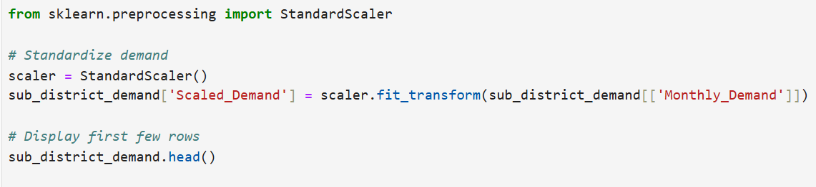

**Visualizing Demand on a Map**  
Geographic data for each sub-district, including latitude and longitude, was used to map demand using Python visualization libraries.

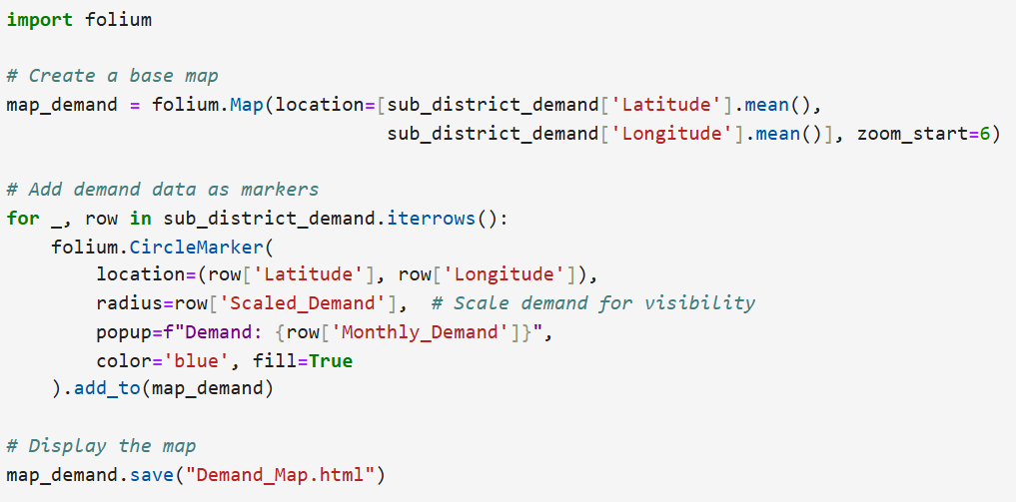

Using data from BONN’s demand points, we mapped high-demand regions on an Indian map. This step allowed us to visualize distribution needs and identify geographic areas with high product consumption. The demand points were marked by state and city, enabling a clear picture of where BONN’s products were most in demand.

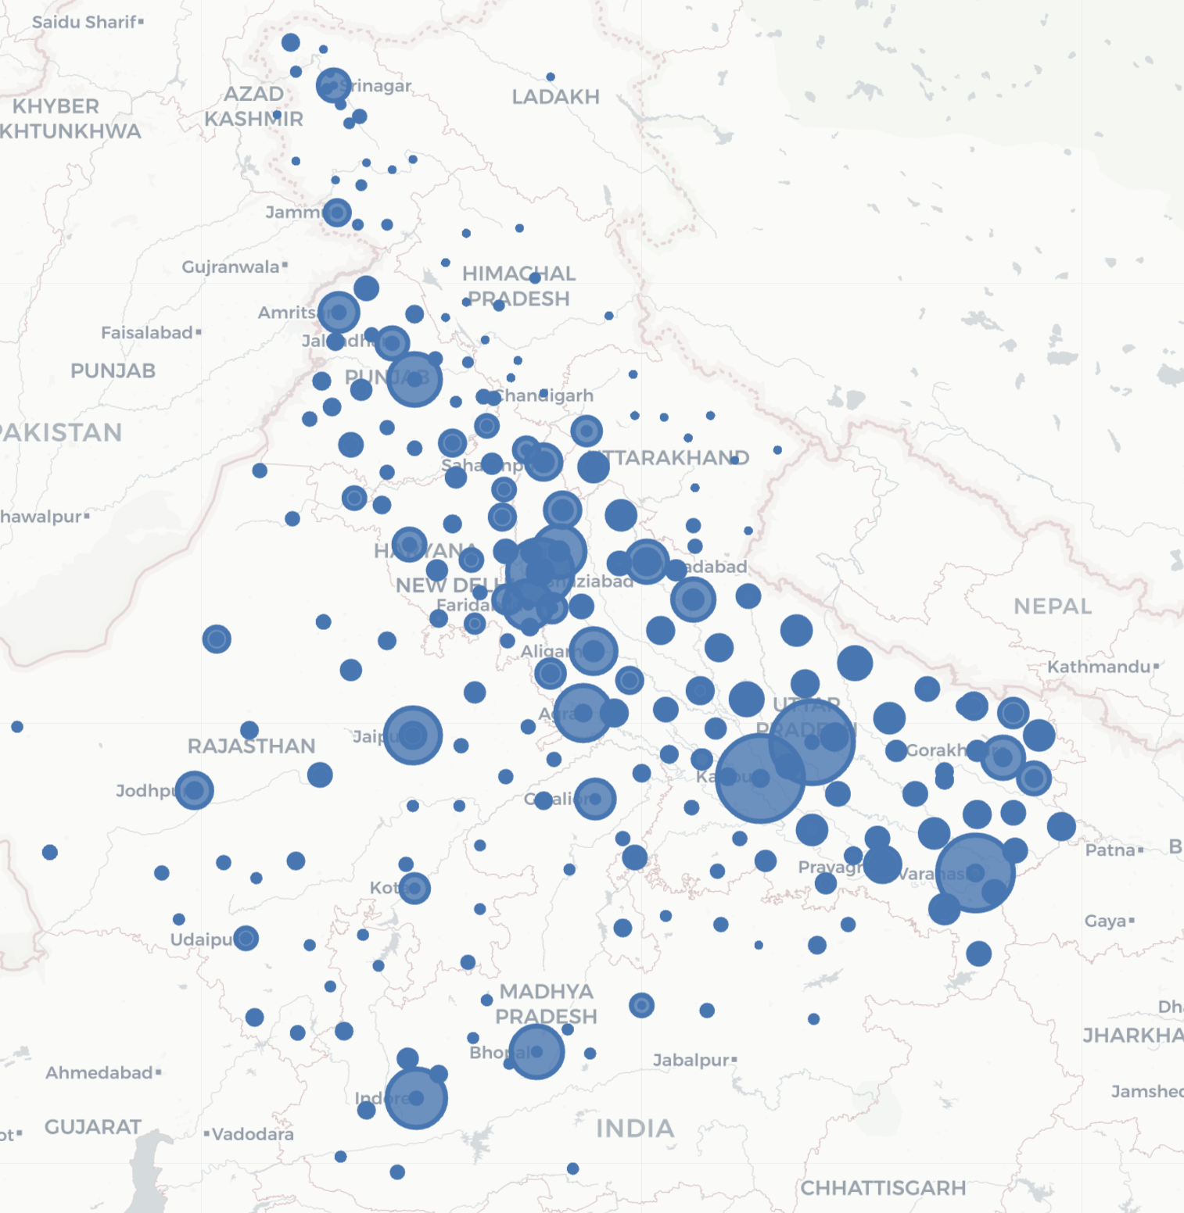

Demand mapping provided:

* A visual representation of BONN’s customer base.
* Insight into regional demand variations.
* A basis for defining clusters and optimizing distribution points.

**3.2 Clustering Techniques**

After identifying key demand locations across India, clustering techniques were employed to group these demand points strategically. This clustering approach aimed to simplify the supply chain network design, allowing for more efficient resource allocation and minimizing transportation costs. We utilized K-means clustering and center-of-gravity calculations, refining our clustering through silhouette scoring and sub-clustering to achieve optimized and manageable clusters.

**K-means Clustering**

**Objective and Overview**: K-means clustering is a popular method for partitioning demand points into clusters based on proximity. In this project, we used K-means to create clusters of demand locations, each representing a group of cities or districts that could be serviced by a single distribution centre. This approach allows for better planning of supply chain routes, ensuring that distribution centers are optimally placed to serve high-demand areas with minimal travel distance.

**Process and Execution**: Using the geographic coordinates (latitude and longitude) of each demand location, we initialized the K-means algorithm with a predetermined number of clusters. The algorithm iteratively assigned each demand point to the nearest cluster centre, recalculating cluster centers based on the mean position of the demand points within each cluster. Through each iteration, the algorithm adjusted the positions of the cluster centers, gradually converging to an optimal configuration where each demand point was grouped with its closest cluster centre.

**Implementation:**

**Clustering with K-Means**  
The K-Means algorithm was used to cluster regions based on Scaled_Demand, Latitude, and Longitude.

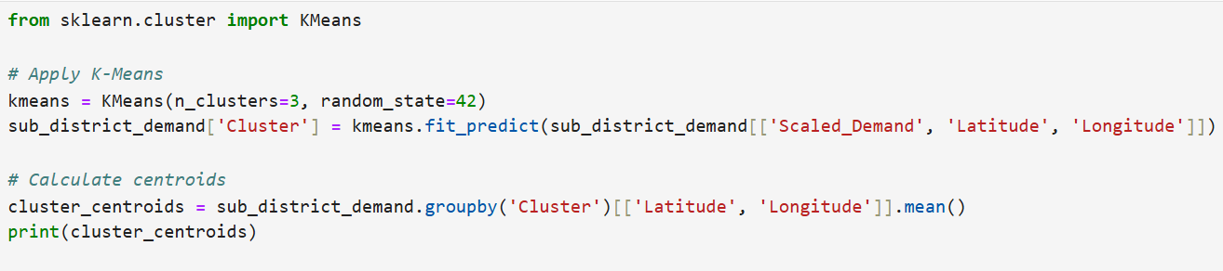

**Visualizing Clusters**  
Clusters were plotted on the map to illustrate the segmentation of demand zones.

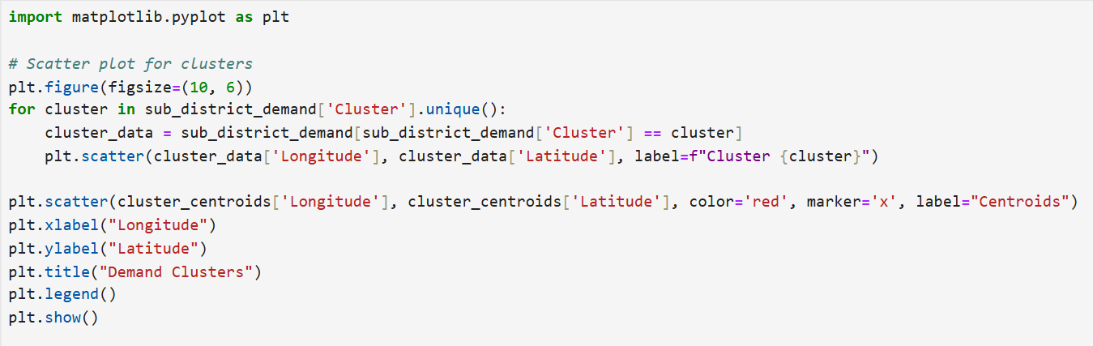

**Silhouette Scoring**: To evaluate the quality of our clustering, we applied silhouette scoring—a measure of how similar each point is to its own cluster compared to other clusters. Silhouette scores range from -1 to +1, with values close to +1 indicating well-defined clusters. By analysing silhouette scores, we fine-tuned the number of clusters, ensuring they provided the best balance between compactness and separation. This scoring helped us prevent over-clustering or under-clustering, maintaining practical and effective groupings of demand points.

### **Geocoding of Latitude and Longitude:**

In supply chain optimization, understanding the geographical distribution of facilities such as warehouses, manufacturing plants, and distribution centers is crucial. This requires accurate geospatial data, which can be obtained by determining latitude and longitude of specific locations and then performing **reverse geocoding** to obtain their corresponding addresses.

This report documents the process of using Python to achieve reverse geocoding, where we input latitude and longitude coordinates and retrieve the corresponding human-readable address. This step is a part of analyzing potential supply chain network nodes.

### **Methodology for Geocoding: Providing Location Names**

We created a list of location names representing potential supply chain nodes such as warehouses or manufacturing plants.  
  
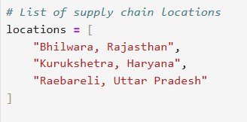

**Implementing Geocoding**

A function, get_coordinates, was developed to convert the provided location names into latitude and longitude. The function:

* Uses the geocoder to fetch the coordinates.
* Handles exceptions such as timeout or service errors for robustness.
* Returns the coordinates or an error message if geocoding fails.

**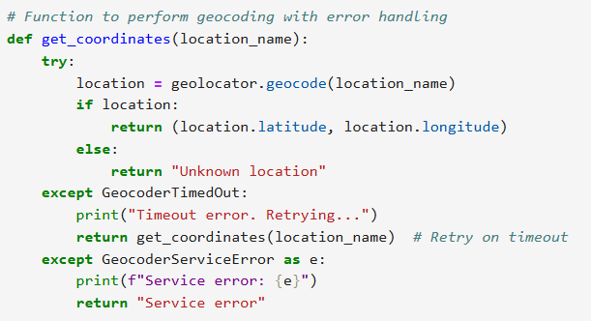  
  
Performing Geocoding for All Locations**

Using a loop, the function get_coordinates was called for each location. A delay of 1 second was introduced between requests to comply with Nominatim’s usage policy.

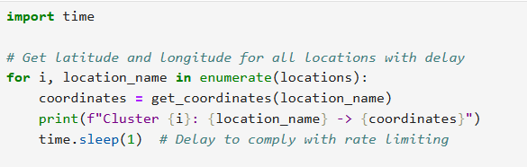

|  |  |  |  |  |
| --- | --- | --- | --- | --- |
| Cluster | Location Name | | Latitude | Longitude |
| 0 | Bhilwara, Rajasthan | 24.85017 | | 75.580538 |
| 1 | Kurukshetra, Haryana | 29.72373 | | 76.769182 |
| 2 | Raebareli, Uttar Pradesh | 26.14164 | | 81.198191 |

**Methodology for Reverse Geocoding:**

**Providing Coordinates**

We prepared a list of latitude and longitude coordinates representing key locations in the supply chain network. These coordinates were collected based on potential warehouse and manufacturing site locations.

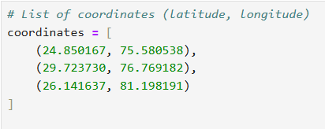

**Implementing Reverse Geocoding**

A function, get_location_name, was developed to perform reverse geocoding. This function:

* Fetches the human-readable address for given latitude and longitude.
* Handles common exceptions such as timeout errors and service errors to ensure robustness.
* Retries in case of a timeout error to avoid loss of data.

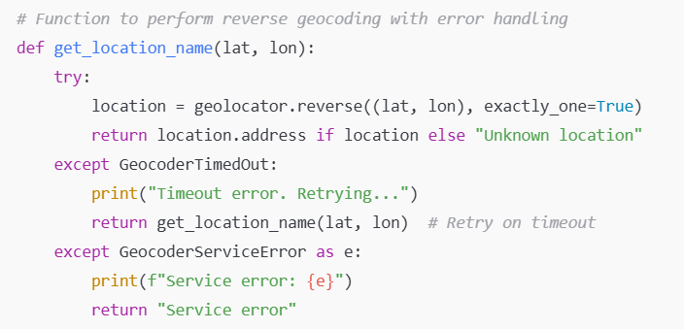

**Performing Reverse Geocoding for Each Coordinate**

Using a loop, the function get_location_name was called for each set of coordinates. A delay of 1 second was introduced between each request to comply with Nominatim’s usage policy.

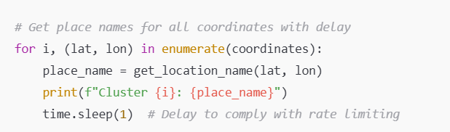

|  |  |  |  |
| --- | --- | --- | --- |
| Latitude | Longitude | District | Sub_District |
| 27.17526 | 78.0098161 | Agra | Agra |
| 26.87065 | 78.49730073 | Agra | Bah |
| 27.23364 | 78.1981356 | Agra | Etmadpur |

**3.3 Sub Clustering**

**Objective**

Divide main clusters into smaller sub-clusters for more granular analysis and planning.

**Implementation:**

**Finding Optimal Sub-Clusters**  
The silhouette score was used to determine the optimal number of sub-clusters within each main cluster.

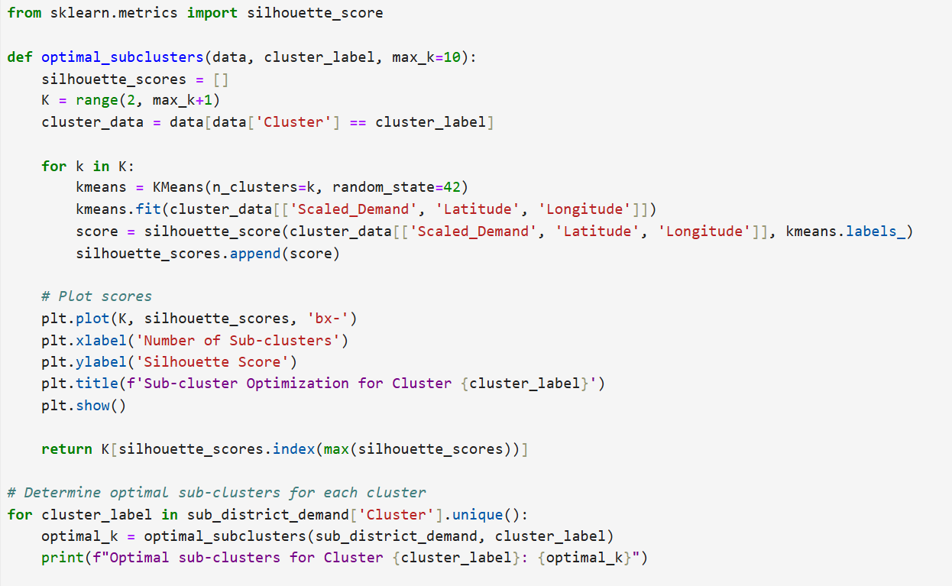

**Assigning Sub-Cluster Labels**  
Sub-clusters were created based on the optimal number of sub-clusters.

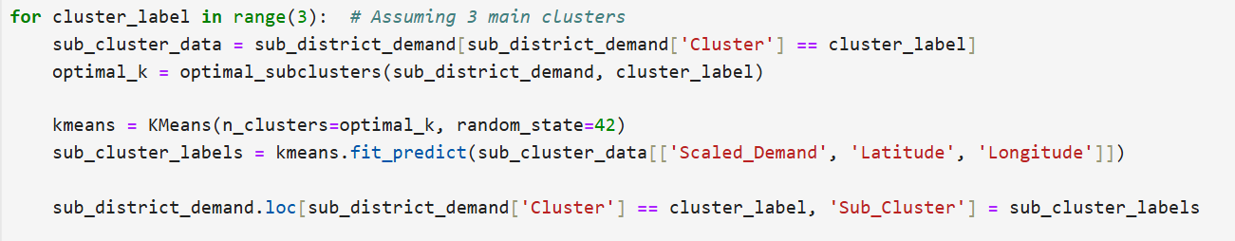

**Finding Out Best Possible Locations**

The **centroid (center of gravity)** for clusters of sub-districts based on their latitude and longitude, the approach involves determining a central geographical point that represents the "average location" of all data points (sub-districts) within a cluster. The centroid is computed as the arithmetic mean of the latitude and longitude coordinates of all sub-districts in a given cluster. This central point acts as the geographical center of the cluster.

**Importance of Centroids**

The centroid concept is extensively utilized in **spatial analysis** to identify central locations that can serve as optimal points for resource allocation, infrastructure placement, and decision-making. Specifically, in **logistics and supply chain management**, centroids are used to enhance operational efficiency by minimizing distances and transportation costs, while improving service delivery.

**Applications in Logistics and Supply Chain Management**

1. **Placing Warehouses**:  
   * By identifying the centroid of demand clusters, warehouses can be strategically located to minimize transportation costs and reduce delivery times.
   * This ensures goods are distributed efficiently to areas with the highest demand concentration.
2. **Establishing Service Centers**:  
   * Service centers, such as repair hubs or customer service locations, can be set up near the centroid of clusters where customer density is highest.
   * This optimizes accessibility and improves customer satisfaction by reducing the distance customers need to travel.
3. **Demand and Supply Analysis**:  
   * Calculating centroids provides insights into geographical demand patterns.
   * Businesses can use this information to strategically adjust inventory levels and supply chain operations based on the distribution of demand.
4. **Strategic Planning**:  
   * Centroids aid in long-term decision-making, such as expanding operations, entering new markets, or reallocating resources to align with demand changes.
   * They also help in evaluating whether existing infrastructure locations are optimal or need realignment.

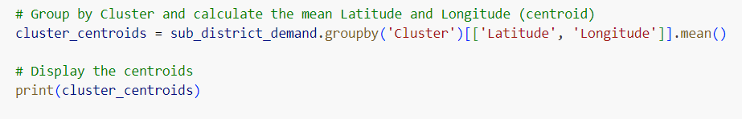

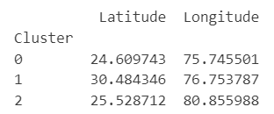

|  |  |  |  |  |  |
| --- | --- | --- | --- | --- | --- |
| Cluster | Location | Tahsil | District | State | Country |
| 0 | Badi | Bhanpura Tahsil | Mandsaur | Madhya Pradesh | India |
| 1 | Budhanpur | Rajpura Tahsil | Patiala | Punjab | India |
| 2 | Baberu | Banda | Uttar Pradesh | India | India |

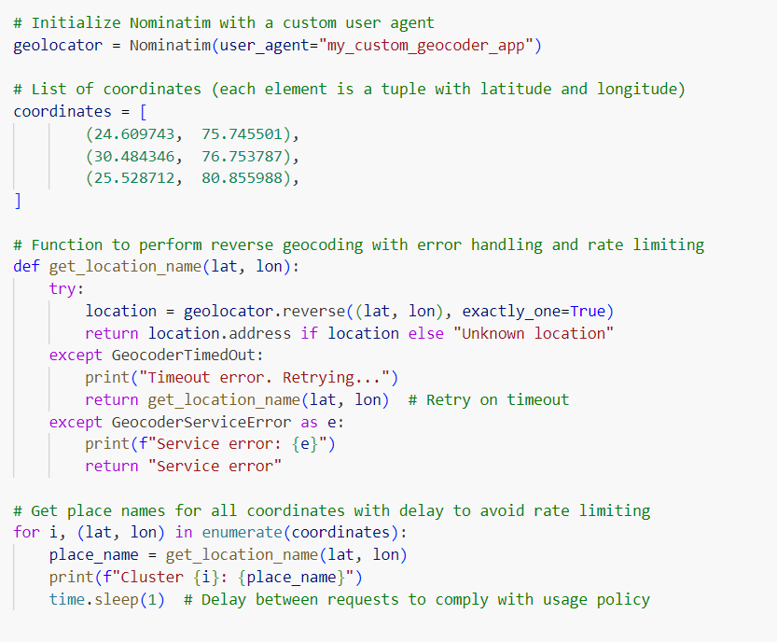

**Weighted Centroids**The process of finding demand-weighted centroids involves calculating a geographical center that accounts for the intensity of demand at various locations. Unlike a simple average, which treats all points equally, demand-weighted centroids give greater importance to locations with higher demand, ensuring the resulting centroid better represents the cluster's "center of gravity" in terms of activity. This approach is especially significant in logistics and supply chain management, where decisions often revolve around optimizing resource allocation and reducing costs.

To calculate the demand-weighted centroid, the latitude and longitude of each sub-district are first multiplied by their respective monthly demand, creating weighted values for each location. These weighted latitudes and longitudes are then grouped by clusters, and their sums are calculated along with the total demand in each cluster. The weighted centroid for each cluster is determined by dividing the summed weighted latitudes and longitudes by the total demand. This ensures that the final centroid is a realistic representation of the geographical center, adjusted for demand variations across the region.

**Importance of Demand-Weighted Centroids**

Demand-weighted centroids are used in scenarios where spatial decisions must consider the intensity of activity or demand at different locations. For example, in **logistics and supply chain management**, demand-weighted centroids are valuable for:

* **Warehouse Placement**: Placing warehouses closer to areas with higher demand reduces transportation costs and improves delivery times.
* **Resource Allocation**: Ensuring that resources like inventory or delivery personnel are optimally distributed based on demand concentration.
* **Service Optimization**: Establishing service centers in locations that maximize accessibility to high-demand areas.

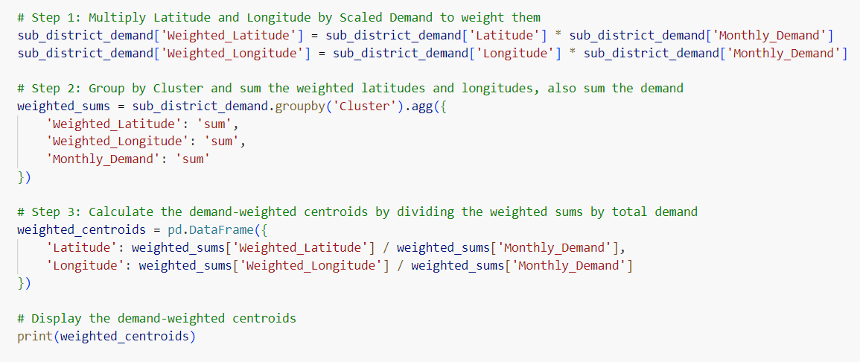

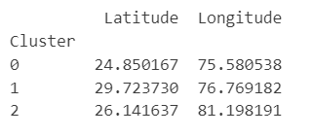

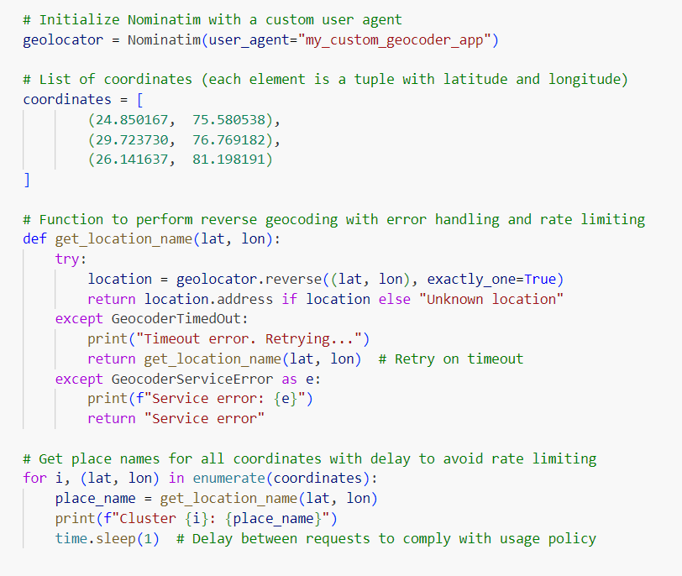

|  |  |  |  |  |  |
| --- | --- | --- | --- | --- | --- |
| Cluster ID | Location | City/Tehsil | District | State | PIN Code |
| 0 | Rawatbhata Tehsil, Chittorgarh, Rajasthan | Rawatbhata Tehsil | Chittorgarh | Rajasthan | 323304 |
| 1 | Nissang, Karnal, Haryana | Nissang | Karnal | Haryana | 132024 |
| 2 | Raebareli, Uttar Pradesh | Raebareli | Raebareli | Uttar Pradesh | 229001 |

**Calculating Weighted Centers of Gravity**  
The weighted center of gravity for each sub-cluster was calculated based on demand.

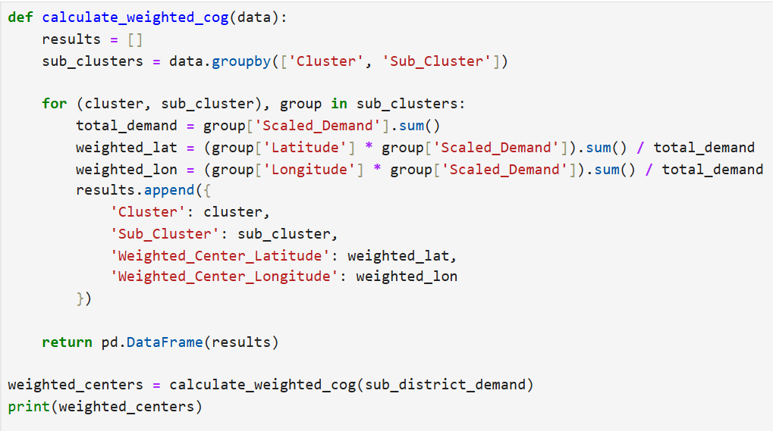

**Visualization Output:**  
Sub-clusters with their weighted centers of gravity were plotted to identify optimal supply chain facility locations.

**Manual Review**

|  |  |
| --- | --- |
| Location | Hempura, Chenpua, Rawatbhata Tehsil, Chittorgarh, Rajasthan |
| Pros | **- Proximity to key industrial hubs in Rajasthan, like Kota - Lower land costs due to rural area, potentially reducing setup expenses - Good highway connectivity** |
| Cons | **- Extreme climate conditions with high summer temperatures, impacting storage and logistics - Limited access to skilled labor; may require additional workforce training** |
| Alternative (Yes/No) | **NO** |
| New Candidate |  |

|  |  |
| --- | --- |
| Location | Raebareli, Uttar Pradesh, 229001 |
| Pros | **- Proximity to Lucknow and Kanpur, which are major cities in Uttar Pradesh - Well-established road and rail connectivity, enhancing distribution capabilities - Access to a large labor pool** |
| Cons | **- Increased competition for resources due to nearby industrial hubs - Seasonal flooding during monsoons could disrupt logistics** |
| Alternative (Yes/No) | **NO** |
| New Candidate |  |

|  |  |
| --- | --- |
| Location | Pehowa, Kurukshetra, Haryana |
| Pros | **- Located near major agricultural areas, beneficial for raw material access - Proximity to Chandigarh and Delhi NCR for distribution - Lower land costs compared to NCR** |
| Cons | **- Limited industrial infrastructure; may require initial setup investment - Traffic congestion on nearby highways, impacting logistics efficiency** |
| Alternative (Yes/No) | **NO** |
| New Candidate |  |

|  |  |
| --- | --- |
| Location | Rajakpura, Chancharsi, Ashta Tahsil, Sehore, Madhya Pradesh |
| Pros | **- Central within Madhya Pradesh, offering access to Bhopal and Indore markets - Lower labor costs due to rural setting - Nearby agricultural resources** |
| Cons | **- Limited rail connectivity and infrastructure in rural areas - Extreme summer and monsoon seasons, which could impact logistics and supply chains** |
| Alternative (Yes/No) | **NO** |
| New Candidate |  |

|  |  |
| --- | --- |
| Location | NH758, Bhawa, Rajsamand Tehsil, Rajsamand, Rajasthan |
| Pros | **- Proximity to NH758 improves logistics - Lower land and operational costs - MSME policies offer tax benefits** |
| Cons | **- Seasonal climate extremes could impact warehousing - Limited skilled workforce availability** |
| Alternative (Yes/No) | **NO** |
| New Candidate |  |

|  |  |
| --- | --- |
| Location | Karahal Tahsil, Sheopur, Madhya Pradesh |
| Pros | **- Cost-effective for land and labor - Agricultural and mineral resources nearby** |
| Cons | **- Remote location with limited access to major markets - Infrastructure may not handle adverse weather well** |
| Alternative (Yes/No) | **NO** |
| New Candidate |  |

|  |  |
| --- | --- |
| Location | Sawayajpur, Hardoi, Uttar Pradesh |
| Pros | **- Close to Lucknow and Kanpur for distribution - Agricultural region with access to raw materials** |
| Cons | **- Infrastructure challenges and limited transport options - Prone to seasonal flooding during monsoons** |
| Alternative (Yes/No) | **NO** |
| New Candidate |  |

|  |  |
| --- | --- |
| Location | Kadipur, Sultanpur, Uttar Pradesh |
| Pros | **- Central location with proximity to urban centers in UP - Favorable labor costs** |
| Cons | **- Road infrastructure may be underdeveloped - High competition in the labor market** |
| Alternative (Yes/No) | **NO** |
| New Candidate |  |

|  |  |
| --- | --- |
| Location | Koriya, Sleemanabad Tahsil, Katni, Madhya Pradesh |
| Pros | - Close to major mining areas - Low land costs in rural area |
| Cons | - Limited access to skilled labor - Seasonal transportation disruptions |
| Alternative (Yes/No) | NO |
| New Candidate |  |

|  |  |
| --- | --- |
| Location | Sonipat, Haryana |
| Pros | **- Proximity to Delhi NCR and Punjab for distribution - Access to skilled labor** |
| Cons | **- Higher land costs due to proximity to NCR - Traffic congestion on major routes** |
| Alternative (Yes/No) | **NO** |
| New Candidate |  |

|  |  |
| --- | --- |
| Location | Tsarkot, Banihal, Ramban, Jammu and Kashmir |
| Pros | **- Scenic location which can attract tourism and workforce - Localized demand for goods** |
| Cons | **- Challenging mountainous terrain affects logistics - Weather issues and accessibility during winter months** |
| Alternative (Yes/No) | **YES** |
| New Candidate | **Udhampur** |

|  |  |
| --- | --- |
| Location | Dhaulana, Hapur, Uttar Pradesh |
| Pros | **- Located near Delhi NCR for fast market access - Established industrial base** |
| Cons | **- High competition for labor and resources - Traffic congestion and high land costs** |
| Alternative (Yes/No) | **NO** |
| New Candidate |  |

|  |  |
| --- | --- |
| Location | Sanot, Nihri, Mandi, Himachal Pradesh |
| Pros | **- Scenic area with potential tourism growth - Low pollution and favorable environment** |
| Cons | **- Remote and mountainous, impacting logistics - Limited access to major markets** |
| Alternative (Yes/No) | **NO** |
| New Candidate |  |

|  |  |
| --- | --- |
| Location | Kimigad Talli, Sananchori, Gairsain, Chamoli, Uttarakhand |
| Pros | **- Proximity to forest resources - Lower land costs** |
| Cons | **- Limited infrastructure and transport access - Subject to landslides and seasonal weather challenges** |
| Alternative (Yes/No) | **YES** |
| New Candidate | **Dehradun** |

|  |  |
| --- | --- |
| Location | Bassian, Raikot Tahsil, Ludhiana, Punjab |
| Pros | **- Agricultural region with access to raw materials - Close to Ludhiana’s industrial area** |
| Cons | **- Pollution concerns due to industrial activities - Limited warehousing options in rural areas** |
| Alternative (Yes/No) | **NO** |
| New Candidate |  |

|  |  |
| --- | --- |
| Location | Udhanwal, Batala Tahsil, Gurdaspur, Punjab |
| Pros | **- Close to Amritsar and the Punjab industrial belt - Moderate land costs** |
| Cons | **- Infrastructure challenges in rural setting - Labor availability fluctuates during harvest seasons** |
| Alternative (Yes/No) | **NO** |
| New Candidate |  |

|  |  |
| --- | --- |
| Location | Chelasri, Rawatsar Tehsil, Hanumangarh, Rajasthan |
| Pros | **- Nearby agricultural regions - Lower operational costs** |
| Cons | **- Extreme temperature variations - Limited skilled labor availability** |
| Alternative (Yes/No) | **NO** |
| New Candidate |  |

### **Finalising Facilities and their Capacities**

### **Logistics Planning**

**1. Third Party vs Self-Sufficient Logistics**

A logistics network can either rely on third-party providers (3PL) or maintain self-sufficient operations. The choice depends on factors such as cost efficiency, flexibility, and control over the supply chain.  
  
**Third Party Logistics**

Third-party logistics involves outsourcing transportation, warehousing, and distribution activities to specialized companies.

**Pros**:

1. **Expertise and Scalability**: Third-party providers often have advanced infrastructure and technology, improving efficiency.
2. **Cost Efficiency**: They aggregate demand, reducing per-unit costs, particularly for small-scale operations.
3. **Focus on Core Business**: Companies can concentrate on production and customer engagement instead of managing logistics.

**Cons**:

1. **Loss of Control**: Reduced oversight on operations might affect service quality.
2. **Dependency**: Over-reliance on third parties could lead to disruptions if their operations are hampered.
3. **Data Security**: Sharing data with third parties can risk confidentiality.

**Self-Sufficiency in Logistics**

This approach involves owning and operating the logistics network, including vehicles, warehouses, and staff.

**Pros**:

1. **Full Control**: Companies can customize operations according to specific needs.
2. **Brand Reputation**: Consistent service enhances customer trust.
3. **Data Ownership**: Sensitive information stays within the organization.

**Cons**:

1. **High Initial Investment**: Requires significant capital for purchasing and maintaining assets.
2. **Complexity**: Managing logistics operations can divert focus from core activities.
3. **Limited Flexibility**: Scaling up or down in response to demand changes can be challenging.

|  |  |  |  |  |  |  |
| --- | --- | --- | --- | --- | --- | --- |
| Provider Name | Cost per KM | Max Capacity | Lead Time | Serviceabilty Coverage Area | Suitable for | Best in which State ? |
| Gati Logistics | 45 | 2000 kg | 1-2 days | Uttar Pradesh, Madhya Pradesh, Punjab,Rajasthan | Factory-Warehouse | Uttar Pradesh |
| Delhivery | 40 | 750 kg | 3 days | Rajasthan, Haryana, NCT of Delhi | Warehouse-Destination | Rajasthan |
| Blue Dart | 50 | 1000 kg | 2 days | Punjab, Haryana, NCT of Delhi | Warehouse-Destination | Haryana |
| Rivigo | 42 | 1500 kg | 1 day | Jammu & Kashmir, Himachal Pradesh, Uttarakhand | Flexible | Jammu and Kashmir |
| Safexpress | 55 | 1200 kg | 2-3 days | Uttar Pradesh, Uttarakhand, Madhya Pradesh | Factory-Warehouse | Madhya Pradesh |
| Om Logistics | 48 | 1800 kg | 1-2 days | Uttar Pradesh, Haryana, Rajasthan, NCT of Delhi | Flexible | Uttar Pradesh |
| TCI Freight | 43 | 3000 kg | 2-3 days | Punjab, Haryana, Uttar Pradesh | Factory-Warehouse | Punjab |
| Spoton Logistics | 46 | 1200 kg | 1-2 days | Rajasthan, Madhya Pradesh, Delhi | Factory-Warehouse | Madhya Pradesh |

|  |  |  |  |  |  |  |  |
| --- | --- | --- | --- | --- | --- | --- | --- |
| Vehicle Name | Capacity per Trip (Tons) | Trips (Total) | Total Capacity Used (Tons) | Qty | Total Fixed Cost (Rs.) | Total Operating Cost (Rs.) |  |
| Eicher Pro 3015 Reefer | 5.5 | 6 (3x2 days) | 33 | 3 | 66,00,000 | 6,30,000 | Chittogarh |
| Tata 407 Gold SFC | 2.2 | 6 | 13.2 | 6 | 75,00,000 | 4,05,000 |
| Ashok Leyland Dost | 1.25 | 6 | 7.5 | 5 | 37,50,000 | 1,35,000 |
|  |  |  |  |  |  |  |  |
| Eicher Pro 3015 Reefer | 5.5 | 6 | 33 | 5 | 1,10,00,000 | 10,50,000 | Raebrelli |
| Tata 407 Gold SFC | 2.2 | 6 | 13.2 | 10 | 1,25,00,000 | 6,75,000 |
| Mahindra Bolero Pik-Up | 1.5 | 6 | 9 | 8 | 64,00,000 | 7,20,000 |
|  |  |  |  |  |  |  |  |
| Eicher Pro Reefer | 2 | 6 | 12 | 6 | 72,00,000 | 12,00,000 | Ludhiana |
| Tata 407 Gold SFC | 2.2 | 6 | 13.2 | 7 | 87,50,000 | 8,10,000 |
| Mahindra Supro Maxitruck | 1 | 6 | 6 | 6 | 33,00,000 | 2,64,000 |
|  |  |  |  |  |  |  |  |
| Eicher Pro Reefer | 5.5 | 6 | 33 | 3 | 66,00,000 | 6,30,000 | Sonepat |
| Tata 407 Gold SFC | 2.2 | 6 | 13.2 | 10 | 1,25,00,000 | 6,75,000 |
| Mahindra Jeeto X7 | 1 | 6 | 6 | 8 | 48,00,000 | 3,68,000 |

FINAL CONCLUSION- We will use Rvigio for J and K, Uttarakhand and Himachal.  
For rest we will use Gati Logistics.

**2. Comparison of Third-Party and Self-Sufficient Models Using Data**

The dataset includes data on vehicles, capacity, and costs. Here's a breakdown:

**Key Observations**:

* **Eicher Pro 3015 Reefer**: High capacity (5.5 tons/trip), moderate operating cost.
* **Tata 407 Gold SFC**: Medium capacity (2.2 tons/trip), lower operating cost.
* **Ashok Leyland Dost**: Low capacity (1.25 tons/trip), lowest cost per trip.

**Third Party Analysis:**

* Fixed costs are avoided, as third parties bear the vehicle and infrastructure costs.
* Operational costs, such as per-trip costs, can fluctuate based on market conditions.

**Self-Sufficiency Analysis:**

* Fixed costs from asset purchases (e.g., Rs. 66,00,000 for Eicher Pro) are substantial.
* Operating costs are predictable but require efficient utilization to remain competitive.

**3. Final Verdict**

Based on the dataset:

* For **short-term or flexible demand**, third-party logistics offers a cost-effective and scalable solution.
* For **long-term and stable demand**, self-sufficiency provides better control and consistent quality, despite higher initial investments.

**Recommendations:**

1. If initial capital is constrained or the logistics network is geographically dispersed, opt for third-party logistics.
2. For critical operations requiring high reliability, consider self-sufficiency, focusing on high-capacity vehicles like the Eicher Pro 3015 Reefer.

**Visualizing the Network & Costing**

**Version 1**

**Network Design and Cost Analysis**

7.1 Proposed Network Layout

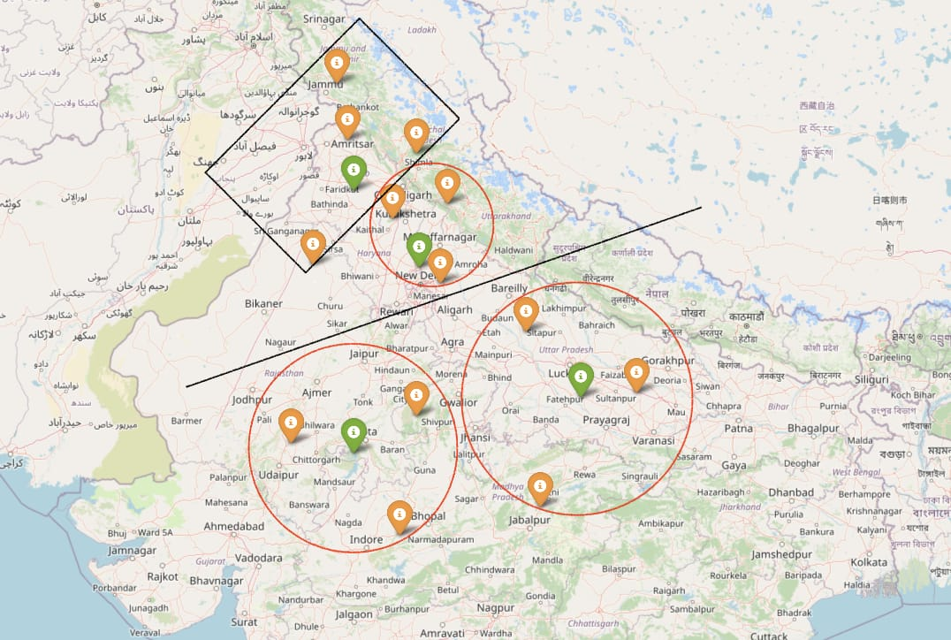

Structure:

* In this version, transportation was based on a traditional hub-and-spoke model.
* Plants supplied products to designated warehouses, and from warehouses, products were distributed to nearby areas.
* The routing did not account for proximity or direct accessibility for areas closer to plants.

Challenges Identified:

* Inefficient Routing: Products were first transported to warehouses, even for regions directly accessible from the plant. This resulted in backtracking.
* Higher Transportation Costs: Additional routes and redundant trips led to increased fuel consumption and time.
* Complex Logistics Management: The system required more trucks and involved more coordination, increasing the operational complexity.

Visualization:

* The image of Version 1 highlights multiple transportation routes where the nearest areas to the plants were unnecessarily supplied via warehouses, causing inefficiencies.

**7.2 Cost Analysis**

|  |  |  |  |
| --- | --- | --- | --- |
| VERSION 1 | | | |
| Cost of Plant to Warehouse | | | |
| Origin | **Weighted Distance Per Day** | **Weighted Distance Per Month** | **Monthly Cost** |
| Chittaurgarh | **7748713** | **232,461,390** | **₹3,486,921** |
| Raibareli | **13782427** | **413,472,810** | **₹6,202,092** |
|  |  | **Sub-Total** | **₹9,689,013** |
|  |  |  |  |
| Cost of Warehouse to Sub Districts | | | |
| Origin | **Weighted Distance Per Day** | **Weighted Distance Per Month** | **Monthly Cost** |
| Rajasmand, RJ | **2284815** | **68,544,447** | **₹1,028,167** |
| Hardoi, UP | **4256423** | **127,692,690** | **₹1,915,390** |
| Sultanpur, UP | **4639940** | **139,198,189** | **₹2,087,973** |
| Katni, MP | **1797700** | **53,931,000** | **₹808,965** |
| Sheopur, MP | **2178061** | **65,341,830** | **₹980,127** |
| Sehore, MP | **2156939** | **64,708,170** | **₹970,623** |
|  |  | **Sub-Total** | **₹7,791,245** |
|  |  |  |  |
|  |  |  |  |
| Rental and Maintenance Cost | | | |
| District | **Warehouse Size (sq ft)** | **Monthly Rent per sq ft (₹)** | **Monthly Rental Cost** |
| Hardoi | **86,600** | **14** | **₹1,212,400** |
| Katni | **35,400** | **17** | **₹601,800** |
| Rajsamand | **40,400** | **18** | **₹727,200** |
| Sehore | **38,800** | **14** | **₹543,200** |
| Sheopur | **43,000** | **20** | **₹860,000** |
| Sultanpur | **119,100** | **15** | **₹1,786,500** |
|  |  | **Sub-Total** | **₹5,731,100** |
|  |  | **TOTAL** | **₹23,211,358** |

|  |  |  |  |
| --- | --- | --- | --- |
| Total Cost Version 1 = | Cost of Transportation to Warehouse | Cost of Warehouse to Sub Districts | Fixed Costs |
|  | **Total Distance x Quantity x Charge** | **Total Distance x Quantity x Charge** | **Estimate** |

**7.3 Pros and Cons**

**Pros:**

1. **Centralized Distribution**: Warehouses act as hubs for supply, making inventory management easier at a centralized level.
2. **Scalability**: Easier to handle growing demand as warehouses can store and redistribute large inventories.
3. **Structured Process**: Defined transportation routes from plants to warehouses ensure predictable logistics.

**Cons:**

1. **High Transportation Costs**: Excessive backtracking and indirect routing increase fuel and time expenses, especially for nearby regions.
2. **Inefficient for Local Deliveries**: Areas near the plants experience delays and unnecessary routing via warehouses.
3. **Resource Wastage**: Underutilization of trucks and inefficient clustering lead to increased operational costs.

**Visualizing the Network & Costing**

**Version 2**

**Network Design and Cost Analysis**  
8.1 Proposed Network Layout

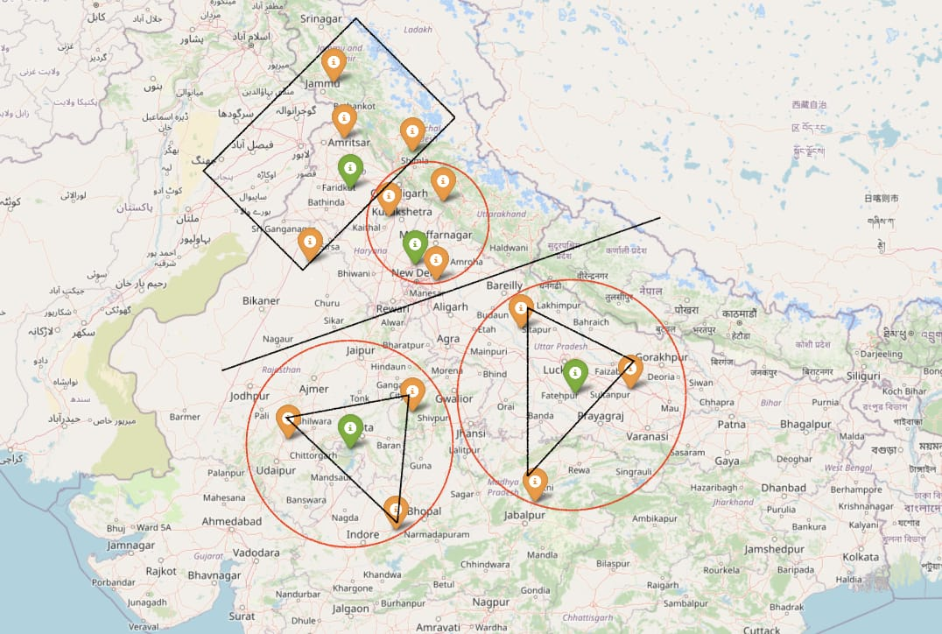

1. Improvements Made:  
   * Introduced clustering and sub-clustering techniques using AI/ML models to group regions based on demand and proximity.
   * Formed triangular regions around each plant, ensuring direct supply from the plant to areas within the triangle.
   * Warehouses were retained for distant regions or as backup for emergency supplies.
2. Key Changes:
   * Triangular Distribution Model: Each plant was connected to regions forming a triangle, minimizing overlapping routes.
   * Direct Supply: Areas close to plants received direct supply, eliminating the need for intermediate warehousing.
   * Demand Forecasting: AI/ML-based centroid clustering was used to predict demand patterns, ensuring accurate distribution planning.
3. Benefits Achieved:  
   * Cost Reduction: Direct routes and clustering reduced transportation costs significantly compared to Version 1.
   * Time Efficiency: Shorter routes and fewer backtracking trips saved time, improving delivery schedules.

|  |  |  |  |  |
| --- | --- | --- | --- | --- |
| VERSION 2 | | | | Effect on Cost |
| Cost of Plant to Warehouse | | | |  |
| Origin | **Weighted Distance Per Day** | **Weighted Distance Per Month** | **Monthly Cost** |  |
| Chittaurgarh | **7009734** | **210,292,010** | **₹3,154,380** | **-9.54%** |
| Raibareli | **10787391** | **323,621,734** | **₹4,854,326** | **-21.73%** |
|  |  | **Sub-Total** | **₹8,008,706** | **-17.34%** |
|  |  |  |  |  |
| Cost of Warehouse to Sub Districts | | | |  |
| Origin | **Weighted Distance Per Day** | **Weighted Distance Per Month** | **Monthly Cost** |  |
| Rajasmand | **1962548** | **58,876,429** | **₹883,146** | **-14.10%** |
| Hardoi, UP | **4225840** | **126,775,191** | **₹1,901,628** | **-0.72%** |
| Sultanpur, UP | **3579654** | **107,389,626** | **₹1,610,844** | **-22.85%** |
| Katni, MP | **1434226** | **43,026,774** | **₹645,402** | **-20.22%** |
| Sheopur, MP | **1712804** | **51,384,134** | **₹770,762** | **-21.36%** |
| Sehore, MP | **1978810.46** | **59,364,314** | **₹890,465** | **-8.26%** |
| Chittaurgarh | **394724** | **11,841,732** | **₹177,626** |  |
| Raibareli | **2491402** | **74,742,050** | **₹1,121,131** |  |
|  |  | **Sub-Total** | **₹5,041,020** | **-35.30%** |
| Rental and Maintenance Cost | | | |  |
| District | **Warehouse Size (sq ft)** | **Monthly Rent per sq ft (₹)** | **Monthly Rental Cost** |  |
| Hardoi | **84,028.59** | **14** | **₹1,176,400** | **-2.97%** |
| Katni | **28,518.82** | **17** | **₹484,820** | **-19.44%** |
| Rajsamand | **39,024.22** | **18** | **₹702,436** | **-3.41%** |
| Sehore | **39,347.60** | **14** | **₹550,866** | **1.41%** |
| Sheopur | **34,058.21** | **20** | **₹681,164** | **-20.79%** |
| Sultanpur | **71,179.53** | **15** | **₹1,067,693** | **-40.24%** |
| Chittaurgarh | **7,848.89** | **15** | **₹117,733** | **-97.95%** |
| Raibareli | **49,540.20** | **15** | **₹743,103** | **-96.80%** |
|  |  |  |  |  |
|  |  | **Sub-Total** | **₹4,663,380** | **-18.63%** |
|  |  | **TOTAL** | **₹17,713,106** | **-23.69%** |

* + Resource Optimization: The need for fewer trucks and less reliance on warehouses lowered overall operational expenses.

1. Visualization:

The image of Version 2 shows the triangular clusters with direct routes from plants to regions, highlighting the reduction in backtracking and unnecessary routes.

**8.2 Cost Analysis**

|  |  |  |  |
| --- | --- | --- | --- |
| Total Cost Version 2 = | Cost of Transportation to Warehouse | Cost of Warehouse to Sub-Districts | Fixed Costs |
|  | **Total Distance x Quantity x Charge** | **Total Distance x Quantity x Charge** | **Estimate** |

**8.3 Pros and Cons**

**Pros:**

1. **Cost Optimization**: Direct routing and triangular clustering minimize transportation costs by eliminating redundant routes.
2. **Efficient Clustering**: Demand fulfillment within triangular clusters reduces the complexity of operations.
3. **Reduced Delivery Time**: Direct supply to nearby areas from plants ensures faster delivery and better resource utilization.
4. **Improved Scalability**: The triangular model allows flexibility to adapt to varying demands in specific regions.

**Cons:**

1. **Initial Complexity**: Requires advanced planning, AI/ML clustering, and demand prediction models, which can be challenging to implement initially.
2. **Dependency on Accurate Data**: The success of the optimization depends heavily on accurate demand forecasts and clustering algorithms.
3. **High Initial Investment**: Setting up optimized transportation routes and implementing AI-based models may require significant initial investment.

**Comparing Costs of Version 1 & Version 2**

The optimization focused on reducing transportation costs and backtracking inefficiencies by improving the routing structure from plants to warehouses and further to sub-clustered regions. This was achieved through advanced clustering techniques and the formation of triangular regions for distribution.

**Version 1**

|  |  |  |  |
| --- | --- | --- | --- |
| Total Cost Version 1 = | Cost of Transportation to Warehouse | Cost of Warehouse to Sub Districts | Fixed Costs |
|  | **Total Distance x Quantity x Charge** | **Total Distance x Quantity x Charge** | **Estimate** |

**Version 2**

|  |  |  |  |
| --- | --- | --- | --- |
| Total Cost Version 2 = | Cost of Transportation to Warehouse | Cost of Warehouse to Sub-Districts | Fixed Costs |
|  | **Total Distance x Quantity x Charge** | **Total Distance x Quantity x Charge** | **Estimate** |

**1. Overview**

Version 1 represents a traditional supply chain model with centralized distribution through warehouses. Goods from production plants are transported to warehouses and then redistributed to various locations.

Version 2 introduces an optimized supply chain approach using triangular clustering and direct routing to eliminate inefficiencies in transportation and delivery.

**2. Cost Comparison**

* Version 1 Total Cost: ₹23,211,358
* Version 2 Total Cost: ₹17,713,106
* Percentage Difference: A cost reduction of 23.69% in Version 2 compared to Version 1.

**Analysis**:  
  
The significant cost reduction in Version 2 highlights the benefits of optimization. Direct routing and clustering lead to more efficient use of resources, such as fuel, time, and manpower, making the supply chain more economical.

**3. Logistics Flow**

* Version 1:
  + Goods flow from plants to warehouses, then from warehouses to end destinations.
  + Leads to longer delivery routes, especially for regions near production plants, causing backtracking and excess fuel consumption.
* Version 2:
  + Goods flow directly to nearby locations from plants while distant regions are serviced using clustered transportation models.
  + Ensures reduced delivery distances, optimized routes, and better fuel efficiency.

**Analysis**:  
  
Version 2’s triangular clustering removes unnecessary warehouse dependency and reduces transit time for nearby areas, ensuring quicker delivery and cost savings.

**4. Operational Efficiency**

* Version 1:
  + Requires more resources for transportation and warehouse operations due to the indirect routing model.
  + Trucks are often underutilized, leading to resource wastage.
* Version 2:
  + Improves resource utilization by assigning direct routes and consolidating deliveries within triangular clusters.
  + Reduces delays and maximizes truck capacity, enhancing overall efficiency.

**Analysis**:  
  
Version 2 leverages advanced optimization techniques, resulting in smoother operations and higher productivity compared to the rigid structure of Version 1.

**5. Scalability and Adaptability**

* Version 1:
  + Centralized warehousing makes it challenging to adapt to fluctuating demand or geographical changes.
  + Scaling operations may require additional warehouse infrastructure, increasing costs.
* Version 2:
  + The triangular clustering model offers greater flexibility to adjust routes based on real-time demand.
  + Can easily scale up or down by modifying clusters without requiring physical infrastructure changes.

**Analysis**:  
  
Version 2’s adaptability makes it a future-proof solution for dynamic supply chain requirements.

**6. Implementation Complexity**

* Version 1:  
  + Simpler to implement as it relies on a straightforward hub-and-spoke model.
  + Does not require advanced tools or demand prediction models.
* Version 2:
  + Requires detailed data analysis, clustering algorithms, and demand forecasts.
  + Involves upfront investment in technology and expertise to set up optimized routes.

**Analysis**:  
  
While Version 2 demands a higher initial investment and planning, its long-term benefits far outweigh these challenges by reducing operational costs and increasing efficiency.

**Conclusion**

Version 2 demonstrates a clear advantage over Version 1 in terms of cost-effectiveness, operational efficiency, and adaptability. The 23.69% cost reduction underscores the impact of optimized logistics. Although Version 2 involves higher implementation complexity, it delivers superior long-term results by streamlining transportation and maximizing resource utilization, making it the preferred choice for modern supply chain systems.

**FINAL SOLUTION**

The Hub-and-Spoke Supply Chain Network Design is a strategic method used to optimize the logistics and transportation aspects of supply chain management. This design centralizes operations through "hubs" that serve as major distribution centers, while "spokes" are the smaller nodes that connect to these hubs, typically representing local warehouses, retail outlets, or customer delivery points.

**Detailed Explanation of the Hub-and-Spoke Model**

1. Structure of the Network:
   * Hubs: Central locations where major storage, sorting, and distribution activities occur. These hubs handle bulk goods and manage long-distance transportation.
   * Spokes: Smaller nodes or locations connected to the hub, serving end consumers or regional facilities.
   * Flow of Goods: Goods are transported in bulk from manufacturers to hubs and then broken down into smaller shipments for distribution to spokes.
2. Operations in the Model:
   * Goods are consolidated at the hubs, reducing the need for direct routes between all locations.
   * Spokes serve regional areas, ensuring localized distribution.
   * Efficient routing and scheduling are prioritized to minimize costs and delivery times.
3. Key Features:  
   * Centralization: Inventory, processing, and management are centralized at the hub, allowing for streamlined operations.
   * Economies of Scale: Bulk transportation to hubs reduces transportation costs significantly.
   * Flexibility: The model adapts well to varying demands at different spokes, ensuring efficient resource allocation.

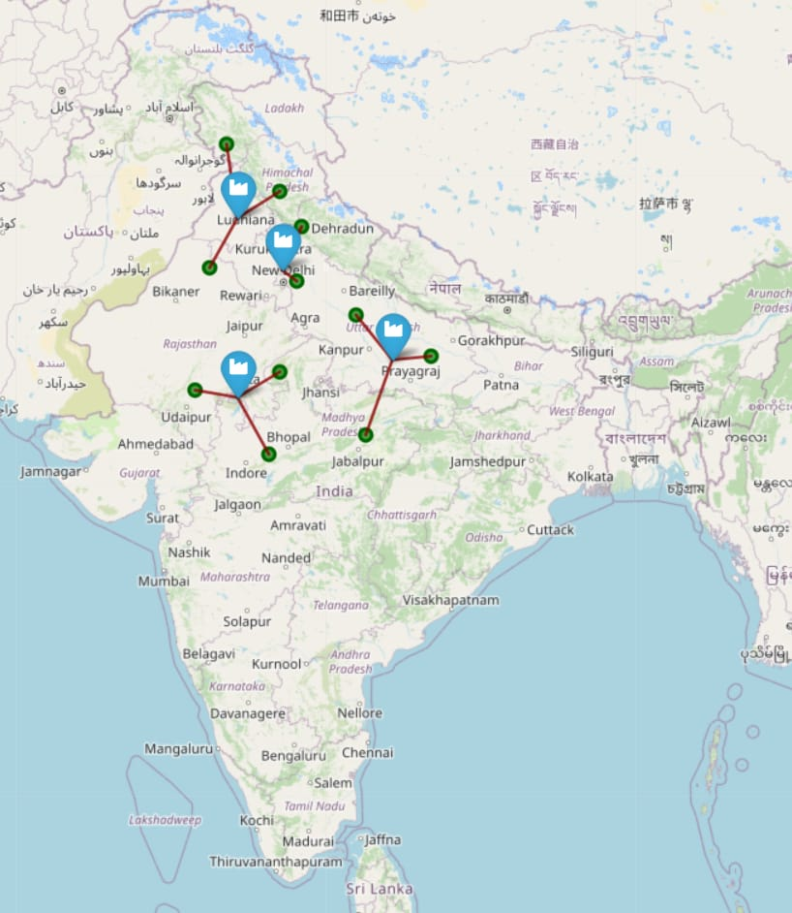

**Why This Method is Optimal**

1. **Cost Efficiency:**
   * The hub-and-spoke model reduces the total number of routes required. Instead of connecting all locations directly (n × (n-1) / 2 routes in a fully connected network), only spoke-to-hub routes are needed (n routes), significantly reducing transportation and operational costs.
   * Bulk transportation to hubs achieves economies of scale, especially for long-haul shipments.
2. **Improved Resource Utilization:**
   * Centralized hubs allow for better utilization of storage space, labor, and transportation resources.
   * Inventory can be strategically distributed to hubs based on demand forecasting, reducing excess stock and minimizing wastage.
3. **Faster Deliveries:**
   * Localized distribution through spokes ensures quicker last-mile deliveries.
   * Hubs can be located strategically near major highways or ports, ensuring smooth inflow and outflow of goods.
4. **Scalability:**
   * This model is highly scalable. New spokes can be added without disrupting the existing hub network.
   * Hubs can be upgraded or expanded as the business grows.
5. **Demand Management:**
   * Hubs act as buffer zones, absorbing fluctuations in demand and ensuring consistent supply to the spokes.
   * The centralized nature of hubs allows for efficient planning during high-demand periods.
6. **Data and Analytics:**
   * Centralized hubs provide a single point to collect data on inventory levels, transportation efficiency, and customer demand, leading to data-driven decision-making.
   * Predictive analytics at hubs help forecast demand and optimize inventory levels at spokes.

**How It Outperforms Other Models**

* **Compared to a Decentralized Model:**
  + Decentralized models require direct connections between every node, leading to higher transportation costs and complexity.
  + Hub-and-spoke models simplify the network structure and reduce redundancies.
* **Compared to a Linear Supply Chain:**
  + Linear supply chains involve sequential flow, which can lead to bottlenecks and delays.
  + Hub-and-spoke networks allow parallel processing and distribution, ensuring smoother operations.

The Hub-and-Spoke Supply Chain Network Design is an optimal solution because it balances cost-efficiency, scalability, and delivery speed. Its structured and centralized approach reduces transportation costs, streamlines inventory management, and enables businesses to meet dynamic demand effectively. Adding this methodology to your report highlights its advantages in reducing costs and improving service quality, demonstrating why it is the preferred choice for modern supply chain networks.

Final Optimal Solution for the Supply Chain Network Design

In our final solution, the hub-and-spoke network has been optimized into a highly efficient model, showcasing three main clusters distributed across India. This solution has been carefully developed to ensure cost minimization, improved transportation efficiency, and seamless integration between production and distribution points**.**

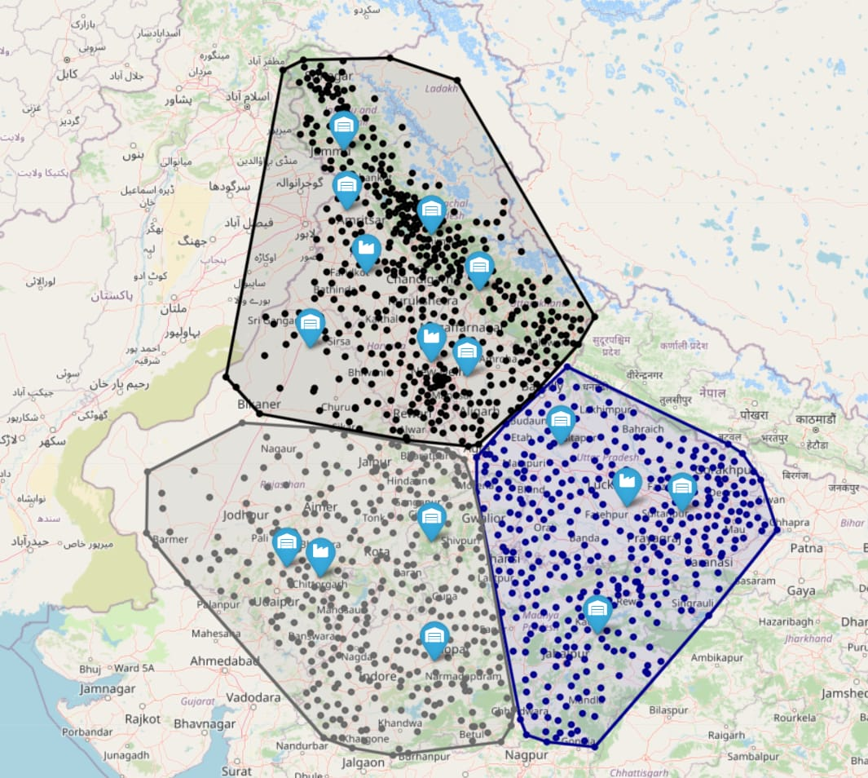

**Below is a detailed explanation of the design and its benefits:**

**Key Features of the Final Solution**

1. **Three Main Clusters:**
   * The supply chain network is divided into three strategically positioned clusters, covering key regions of the country.
   * Each cluster is designed to balance supply and demand, ensuring efficient flow from plants to warehouses. The warehouses within each cluster are carefully mapped to align with the transportation routes, minimizing travel distances and time.
2. **Plant-to-Warehouse Flow:**
   * Goods are transported from plants to warehouses in their respective clusters based on demand distribution.
   * The hub-and-spoke model enables a centralized flow, where the plants act as hubs and the warehouses serve as spokes, ensuring effective regional coverage without unnecessary overlaps.

**Advantages of the Final Solution**

1. **Cost Optimization:**
   * The total cost of this version is ₹17,713,106, reflecting a 23.69% reduction compared to the previous version, which cost ₹23,211,358.
   * This is achieved through improved allocation of warehouses to plants and optimized transportation routes**.**
2. **Transportation Efficiency:**
   * By clustering warehouses based on geographical proximity to plants, the transportation distances have been significantly reduced. This minimizes fuel consumption, time delays, and logistics expenses.
3. **Improved Responsiveness:**
   * The cluster-based approach ensures quicker delivery times and enhanced responsiveness to regional demand fluctuations, improving overall supply chain performance**.**
4. **Streamlined Operations:**
   * The elimination of overlapping routes and redundant transportation pathways reduces operational complexity, ensuring smooth coordination between plants and warehouses.

**How the Clusters Work**

* The map visualizes the network flow from plants to warehouses with clearly defined routes.
* Each cluster forms a distinct operational zone where plants supply their respective warehouses based on demand, creating a well-distributed and organized supply chain.

The pathways on the map highlight the connectivity within each cluster, ensuring the shortest possible routes between plants and warehouses.

|  |  |  |
| --- | --- | --- |
| Aspect | Version 1 | Version 2 (Final) |
| Total Cost | ₹ 2,32,11,358 | ₹ 1,77,13,106 |
| Percentage Reduction | - | **23.69% less** |
| Transportation Design | Overlapping and inefficient | Cluster-based and optimized |
| Delivery Speed | Moderate | Faster due to regional focus |
| Operational Complexity | High | Low |

**Conclusion**

This final version represents the optimal supply chain design, achieving a balance between cost efficiency and operational effectiveness. By leveraging the hub-and-spoke model and dividing the network into three distinct clusters, this solution not only minimizes logistics costs but also ensures faster deliveries and streamlined processes. This optimized design provides a scalable framework for future supply chain expansions, making it sustainable and adaptable to evolving business needs.

**The Future of AI/ML in Supply Chain Management**



**1. Introduction**

* Briefly introduce the importance of supply chain management (SCM) in industries.
* Highlight the growing complexity of SCM due to globalization and demand variability.
* Emphasize how Artificial Intelligence (AI) and Machine Learning (ML) are transforming SCM.
* Add a note on the relevance of your project in this context.

Artificial Intelligence (AI) and Machine Learning (ML) have emerged as transformative tools to address these challenges. With their ability to process vast amounts of data and generate actionable insights, AI and ML are revolutionizing supply chain operations. From predictive analytics to route optimization, these technologies are driving a new era of efficiency and innovation.

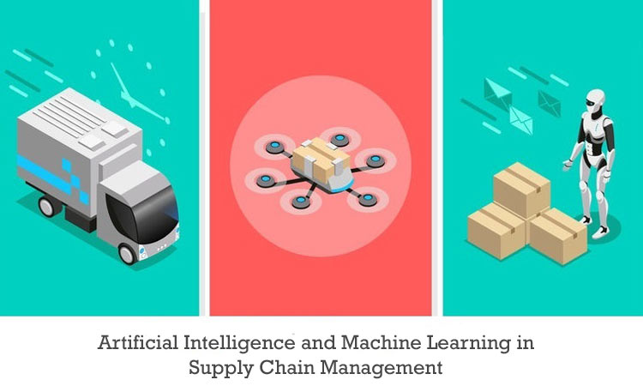 **2. The Role of AI/ML in Supply Chain Management**

AI and ML technologies are being increasingly integrated into supply chain operations to improve efficiency, reduce costs, and ensure timely delivery. Their role spans across various stages of the supply chain:

* Demand Forecasting: AI algorithms analyze historical data, market trends, and external factors such as weather or economic conditions to accurately predict demand. This helps in maintaining optimal inventory levels and reducing stockouts or overstocking.
* Route Optimization: Machine learning models evaluate real-time traffic, weather, and delivery schedules to optimize routes, saving time and fuel.
* Risk Management: AI-based systems identify potential risks in the supply chain, such as supplier delays or geopolitical disruptions, and provide proactive mitigation strategies.
* Inventory Management: ML models predict reorder points, optimize stock levels, and reduce waste by identifying slow-moving inventory.
* Automation in Logistics: AI-driven robotics and autonomous systems are revolutionizing warehouse operations and last-mile deliveries.

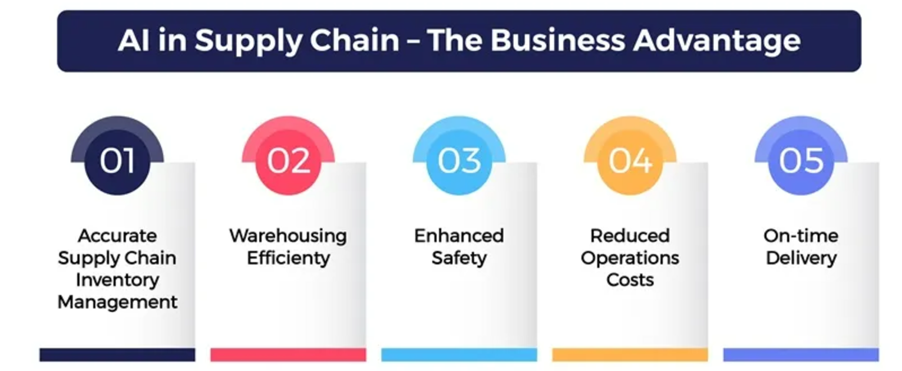

**3. Emerging Trends in AI/ML for Supply Chain**

As the adoption of AI and ML grows, several trends are shaping the future of supply chain management:

* AI-Powered Predictive Analytics: This trend involves analyzing real-time and historical data to anticipate demand, optimize production schedules, and adjust supply chain operations accordingly.
* Smart Warehousing: AI-powered robots and automated guided vehicles (AGVs) are transforming warehousing operations by automating tasks such as picking, sorting, and packing.
* Integration with IoT: The Internet of Things (IoT) provides real-time data on shipments, inventory, and equipment performance. Combined with AI, this data enables predictive maintenance and better tracking.
* Digital Twins: Digital twin technology creates virtual models of supply chain networks, allowing companies to simulate and test scenarios before implementing changes.

**4.Challenges in Implementing AI/ML in Supply Chains**

Despite its potential, the implementation of AI/ML in supply chains is not without challenges:

1. High Initial Costs: Deploying AI/ML systems involves substantial investments in infrastructure, software, and talent acquisition.
2. Data Quality Issues: The effectiveness of AI models depends on the quality and quantity of data. Poor data can lead to inaccurate predictions and decisions.
3. Skill Gap: The lack of skilled professionals who understand both supply chain operations and AI/ML technologies is a major barrier.

**5. Case Study: Cost Optimization in Bonn Supply Chain**

**Overview of the Project:**

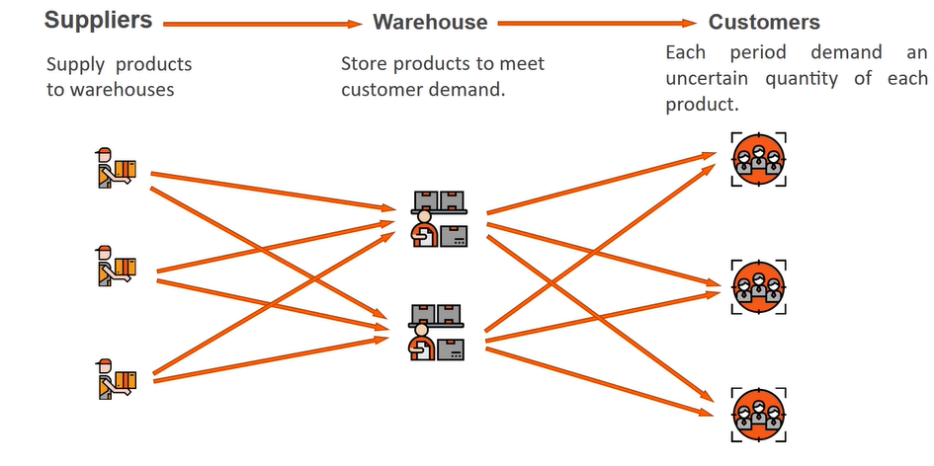 **In our project with the Bonn Company, we utilized AI/ML technologies to optimize supply chain costs in North India. Here’s an outline of our approach:**

1. **Plant Setup:**
   * Identified four strategic plant locations based on population density and demand.
   * Used weighted centroid analysis to ensure demand coverage across regions.
2. **Warehouse Clustering:**
   * Created clusters and sub-clusters using AI-based algorithms to identify optimal warehouse locations.
   * Assigned each warehouse to a plant based on proximity and demand.
3. **Transportation Optimization:**
   * Analyzed transportation routes and decided on a mix of owned, rental, and emergency trucks.
   * Formed triangular areas around plants to minimize transportation distances (Version 1).
   * Compared costs before and after optimization, showing significant improvements.
4. **Web Application:**
   * Developed a MERN stack web app to visualize data, including clustering models, cost analyses, and optimization results.

**Future Directions and Opportunities**

**The future of AI/ML in supply chain management is filled with opportunities:**

1. Sustainability: AI can optimize supply chain operations to reduce carbon footprints by identifying eco-friendly routes and minimizing waste.
2. Blockchain Integration: Combining AI with blockchain ensures secure, transparent, and traceable supply chain transactions.
3. Personalization: AI can analyze customer preferences to enable more personalized product recommendations and supply chain strategies.
4. Advanced Robotics: AI-powered robotics will play a greater role in automating warehouse and delivery tasks.
5. Global Connectivity: AI systems will facilitate seamless collaboration across international supply chains, improving agility and resilience.

**Conclusion**

AI/ML technologies are set to redefine the future of supply chain management. From improving efficiency and reducing costs to enhancing customer satisfaction, their potential is vast. Our project with Bonn Company showcased the transformative impact of AI/ML in cost optimization and resource management. As industries continue to adopt these technologies, the supply chain landscape will become more innovative, sustainable, and resilient.